SOP: Creation of Resource Group in Azure
1. Login to Azure Portal
- Navigate to: https://portal.azure.com
- Login with authorized credentials.

2. Navigate to Resource Groups
- In the search bar, type Resource Groups
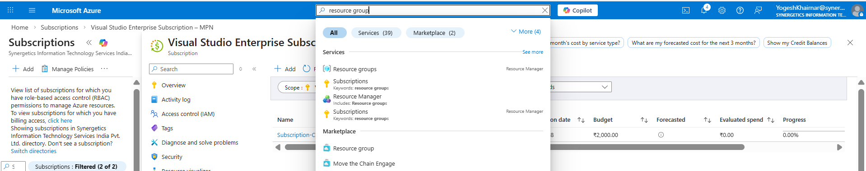
- Click on Resource Groups
- Click + Create

3. Configure Basics
Fill the following details:
- Subscription → Select required subscription
- Resource Group Name → Follow naming convention
- Region → Choose region according to your requirement.
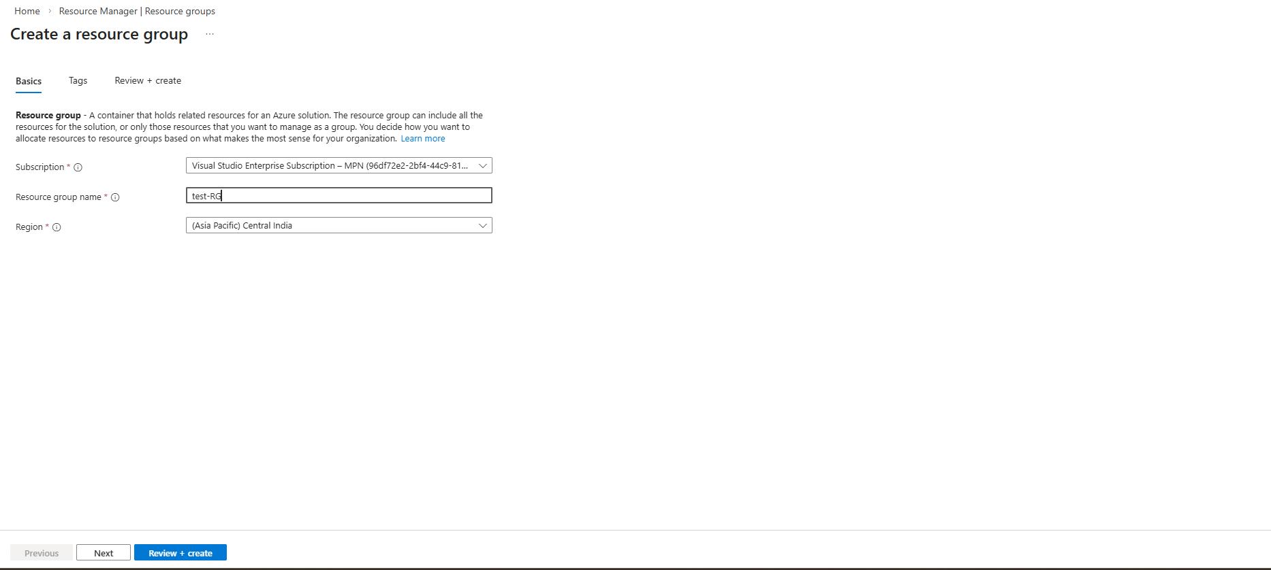

5. Review + Create
- Click Review + Create
- Validate configuration
- Click Create
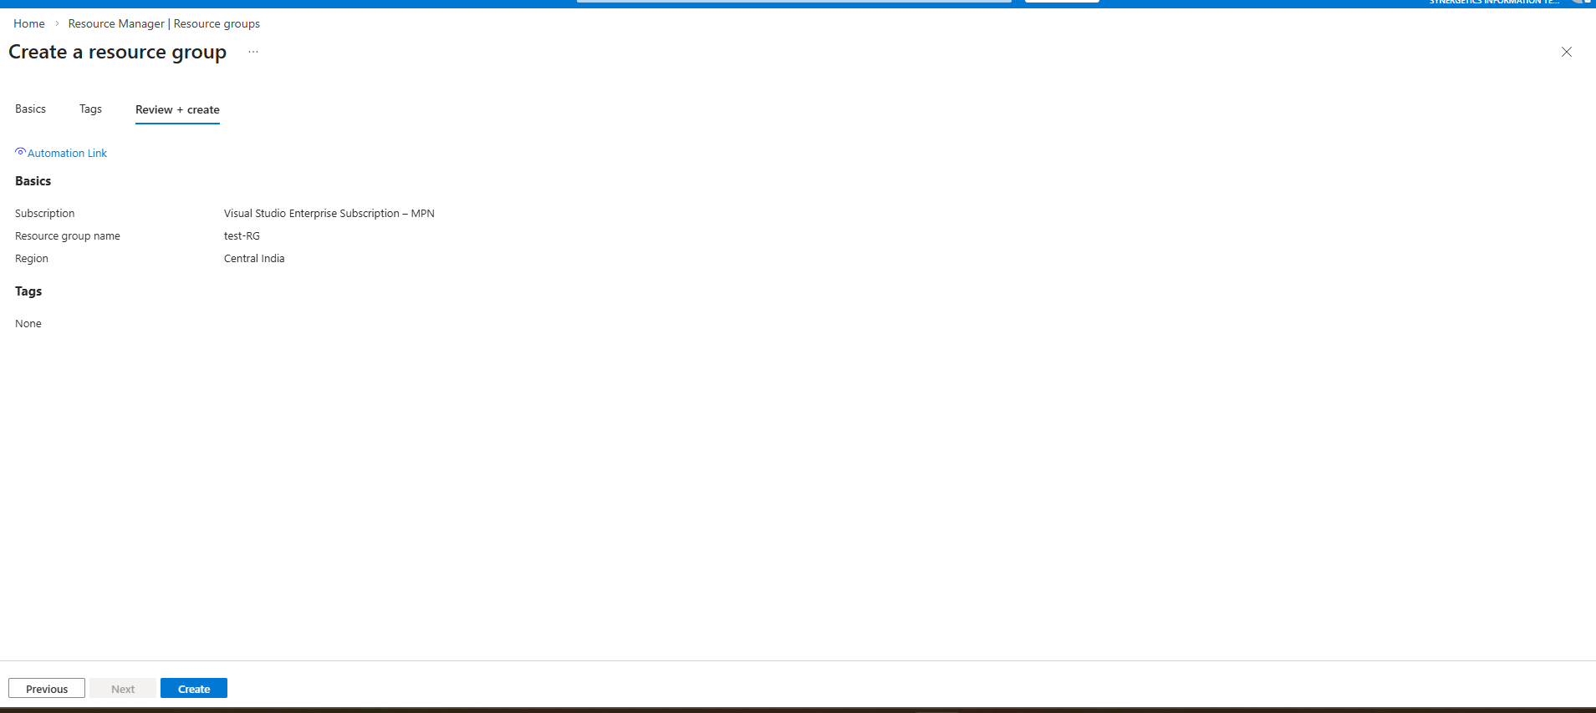
Resource Group will be created successfully.
Deletion of resource group and the resource deployed in that resource group .
Navigate to resource group which you have created > Click on delete resource group.
all the resources which are deployed in that resource group will be deleted.
